|  |
| --- |
| Webgl based product marketing development |
| Gram Tarang Technologies |

## Overview

|  |  |
| --- | --- |
| Badge Tick1 with solid fill | WebGL-based product marketing development with 3D models offers a cutting-edge approach to showcasing and promoting products online. By leveraging the power of WebGL, a web-based graphics library, marketers can create immersive and interactive experiences that bring products to life. With WebGL, 3D models can be rendered directly in a web browser, allowing users to explore products from every angle, zoom in and out, and even interact with certain features. This technology enables customers to have a realistic and engaging product experience, enhancing their understanding and increasing their confidence in making a purchase. By incorporating WebGL-based product marketing, businesses can create visually stunning presentations, deliver a more memorable brand experience, and ultimately drive higher customer engagement and conversion rates. |

## Project scope

|  |  |
| --- | --- |
| Badge Tick1 with solid fill | The scope of WebGL-based product marketing development with 3D models using Blender and Unity 3D is to create an interactive and visually captivating marketing experience for products. This project involves the creation of accurate and visually appealing 3D models using Blender, including the modeling of various components, surfaces, textures, and materials. These models are then enhanced with animations and textures to showcase the product functionalities and provide a realistic look and feel.  The scope also encompasses user interaction and customization options within the web-based application. Users can engage with the 3D models by rotating, zooming, and selecting different parts or configurations. Additionally, customization features may be implemented, allowing users to modify colors, materials, or product variations, providing a personalized and engaging experience. |

## High-level requirements

|  |  |
| --- | --- |
| Badge Tick1 with solid fill | 1. Blender  2. Unity 3D  3. Adobe Substance Painter |

## Deliverables

|  |  |
| --- | --- |
| Badge Tick1 with solid fill |  |
|  |  |

## Affected parties

|  |  |
| --- | --- |
| Badge Tick1 with solid fill | * Business/Company * Customers/Users * Marketing and Sales Teams * Development Team * Project Stakeholders * Collaborators/Partners * Competitors |

## Affected business processes or systems

|  |  |
| --- | --- |
| Badge Tick1 with solid fill | * Product Marketing and Promotion * Product Presentation and Demonstration * Customer Engagement and Interaction * Sales and Conversion * IT Infrastructure and Hosting * Collaboration and Communication * Branding and Image * Competitor Analysis |

## Specific exclusions from scope

|  |  |
| --- | --- |
| Badge Tick1 with solid fill | 1. Backend Development 2. E-commerce Functionality 3. Augmented Reality (AR) or Virtual Reality (VR) Integration 4. Content Creation 5. Localization and Multi-language Support 6. Search Engine Optimization (SEO) 7. Maintenance and Support |

## Final Output

|  |  |
| --- | --- |
| Badge Tick1 with solid fill |  |

## Implementation plan

|  |  |
| --- | --- |
| Badge Tick1 with solid fill | 1. Project Initiation:  * Outlined project objectives, scope, and deliverables. * Allocated necessary resources, including software, and hardware.  1. Requirements Gathering:  * Identified the specific 3D models to be created and their associated animations and textures. * Determined the desired user interaction and customization features.  1. 3D Modeling and Animation:  * Used Blender to create high-quality 3D models of the products, ensuring accuracy and visual appeal. * Applied animations and textures to the models, showcasing product functionalities and features. * Optimized the models and animations for efficient rendering in WebGL.  1. Integration with Unity 3D:  * Imported the 3D models, animations, and textures into Unity 3D. * Set up of the scene, camera, lighting, and other necessary components in Unity. * Configured interactions and customizations using Unity's scripting capabilities.  1. Testing and Quality Assurance:  * Conduct thorough testing to ensure functionality, and performance. * Iterated on improvements based on user feedback and testing results.  1. Documentation and Deployment:  * Prepared this comprehensive project documentation. * Ensured that all necessary files, assets, and dependencies are included.  1. Project Presentation:  * Prepared a project presentation to showcase the objectives, implementation, and outcomes. |

## Timeline

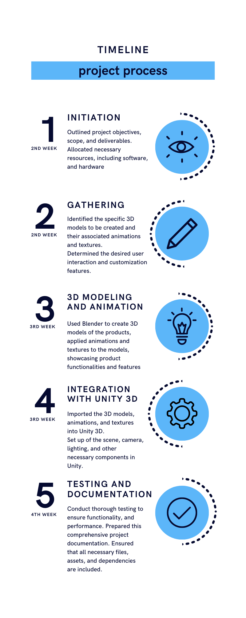

## References 1. Thomas Brush - [How to make UI in UNITY](https://www.youtube.com/watch?v=_RIsfVOqTaE) 2. <https://learn.unity.com/tutorial/creating-and-publishing-webgl-builds>

## Team

JSK Hema Shri – 201801330033  
M Sreeram Suraz – 211801390014  
Ankita - 211207140023